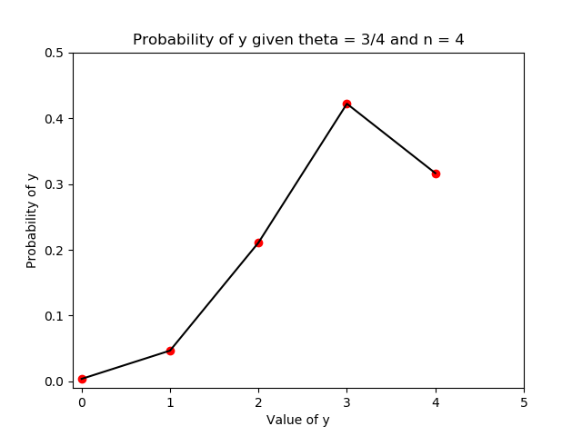

Above is the graph of the probability distribution regarding y given the theta of ¾ and n of 4 trials.

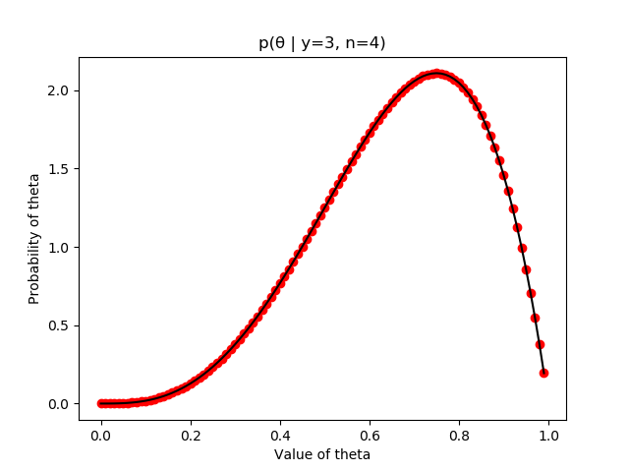

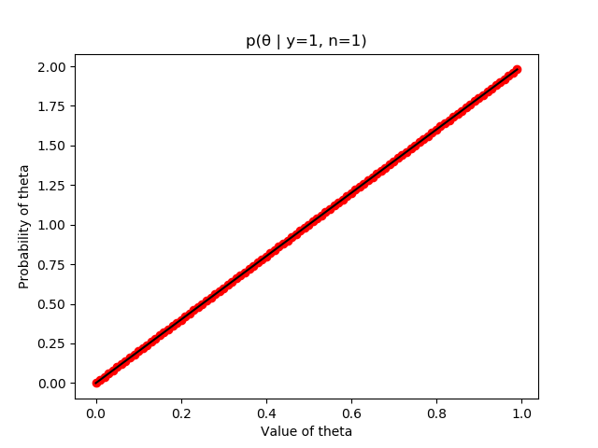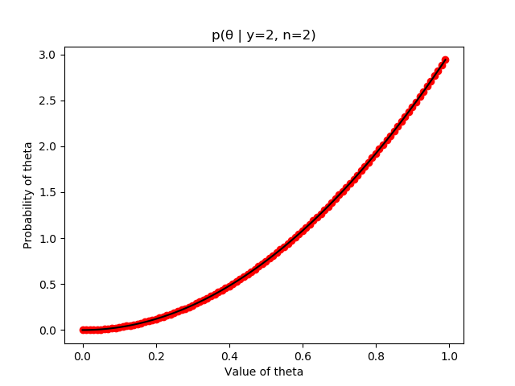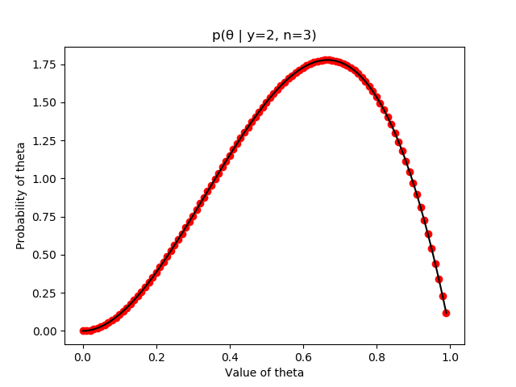

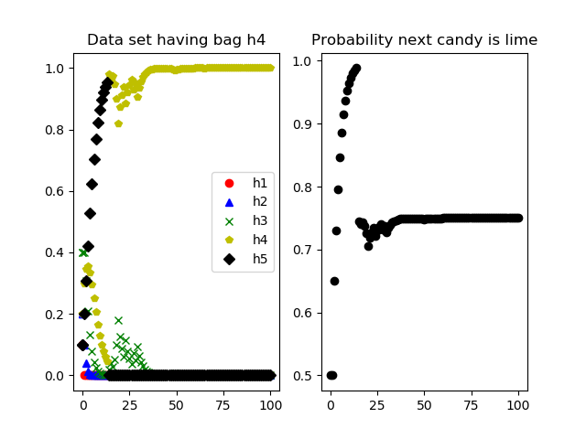

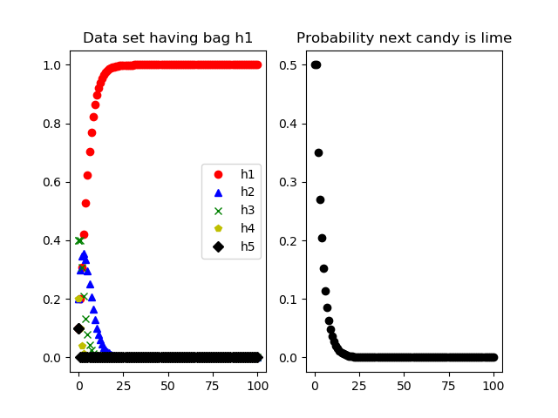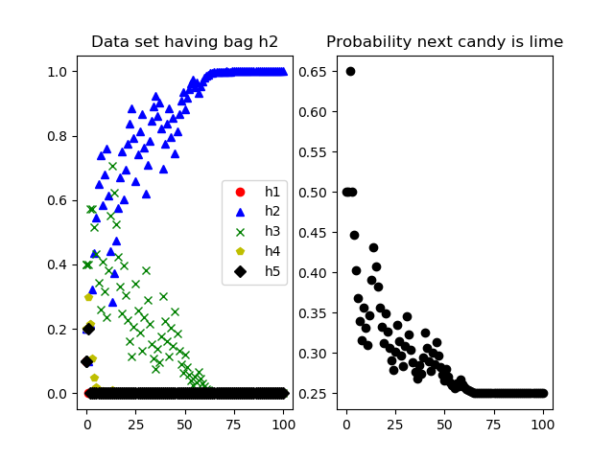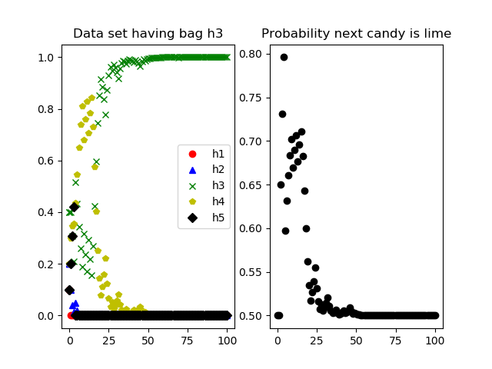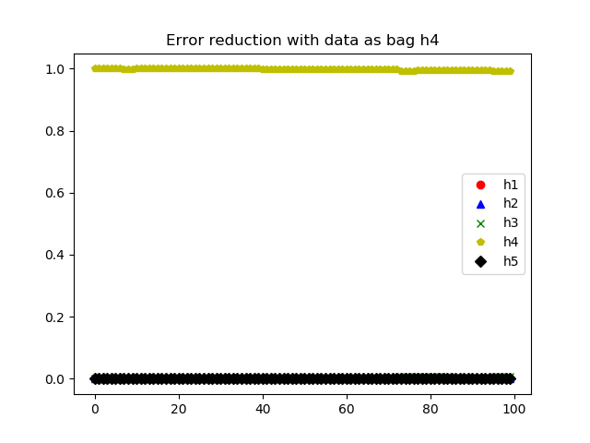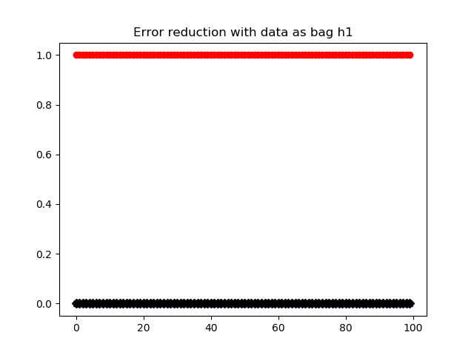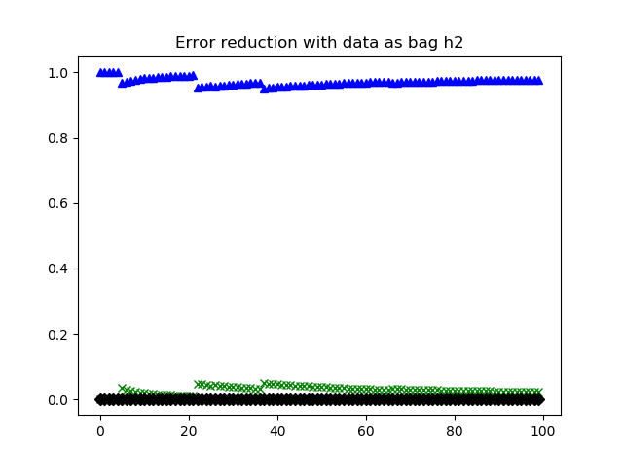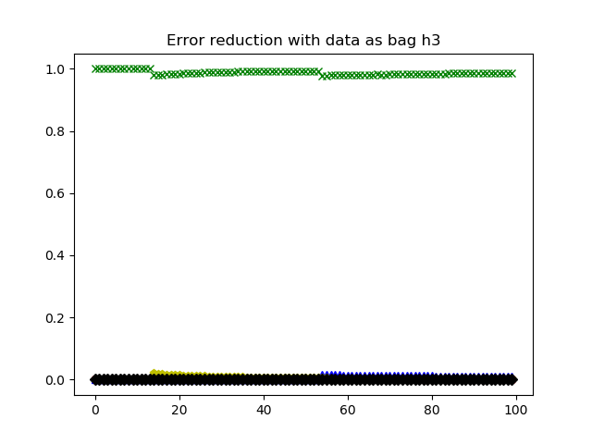

Analysis

1. The graphs regarding the distribution of the coin flips accurately depicts the expected values for the probability of how many heads you would get given that weight of ¾ favoring heads for 4 trials. For part C, the graphs of the changing values of the probability distribution of theta, these show similar steps to what was shown in class, where the mean generally hovers around the direct proportion of heads to tails, and show the proper distributions at each point.
2. Part A analysis
   1. For part A, the graphs for each bag data set show the convergence to the correct value, according to what is most likely to be the bag. It shows each step, with the x axis representing the number of candies opened, and the y axis the likelihood that the bag we have is that bag hi. For each of these 4 data sets, the correct graph does win out in the end, but the changes in probability of each are very interesting to follow, especially that of graph with the bag h4, since we draw an immediate estimated 10 lime candies in a row, thus increasing the probability of h5, until a cherry is drawn, dropping h5 down to 0 immediately.
   2. Part B is written out
   3. For part c, the graph of the average ending values, with the graph showing the running average during each of the 100 trials of 100 candies, is shown for each of the four bags. As time goes on, one would expect that there would be little to no variance in terms of which values were the “correct” bags, but due to the nature of randomness, the values did change, with a few trials where the bag was incorrectly classified.

All graphs will be shown with new random data upon each running of programs.py